**Laguna College**

**San Pablo City**

**ITE Department**

**CS Elec 1 – Computational Science**

**Chapter 1: Basic Python Programming**

**Set A : Math Area Formula**

Name : ____________________________ Date: ___________

Create a program which will ask the user which of the 3 shape areas the user would like to compute and the unit in length (cm, m, km, mm).

**List of choices**

S – Square

R – Rectangle

T - Triangle

**The program will stop running unless incorrect choice was inputted.**

Details

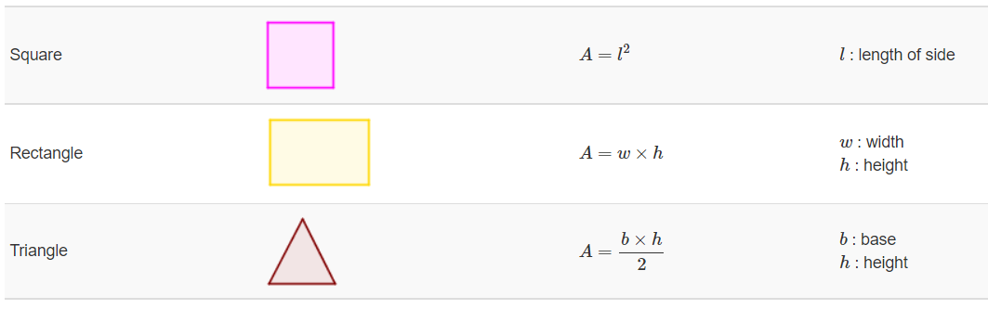

Once the user chooses valid options from S, R and T, the program will run accordingly and will show the computed area of the chosen shape with the given unit.

Inputs which are negative will not be accepted.